**Hands-on Lab : Basics of SQL SELECT Statement**

**TASK A e B**

1. Suppose we want to retrieve details of all the films from the "FilmLocations" table. The details of each film record should contain all the film columns.

*SELECT \**

*FROM FilmLocations*

*;*

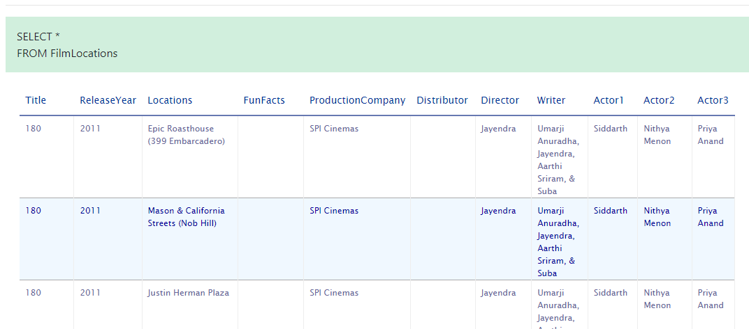

1. Now we want to retrieve selective details of all the film records. Let us retrieve the names of all the films along with director names and writer names.

*SELECT Title, Director, Writer*

*FROM FilmLocations*

*;*

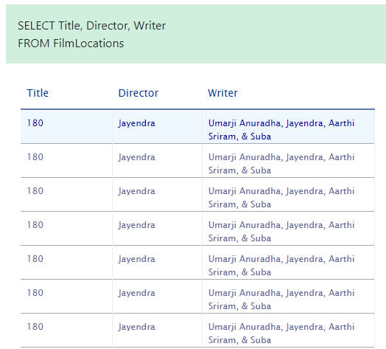

1. We want to retrieve film names along with filming locations and release years. But we also want to restrict the output resultset so that we can retrieve only the film records released in 2001 and onwards (release years after 2001 including 2001).

*SELECT Title, ReleaseYear, Locations*

*FROM FilmLocations*

*WHERE ReleaseYear >= 2001*

*;*

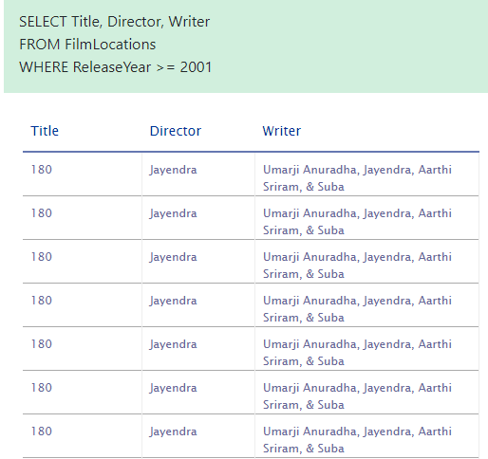

**Task C: Practice exercises on SELECT statement**

Finally, let us practice creating and running some SELECT queries.

1. Problem:

*Retrieve the fun facts and filming locations of all films.*

SELECT FunFacts, Locations

FROM FilmLocations

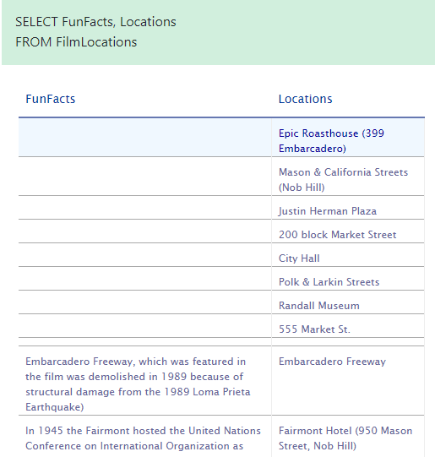

1. Problem:

*Retrieve the names of all films released in the 20th century and before (release years before 2000 including 2000) that, along with filming locations and release years.*

*SELECT Title, Locations, ReleaseYear*

*FROM* FilmLocations

*WHERE ReleaseYear <=2000*

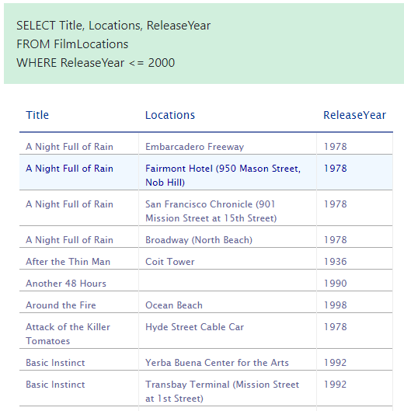

1. Problem:

*Retrieve the names, production company names, filming locations, and release years of the films which are not written by James Cameron.*

*SELECT Title, Locations, ReleaseYear, ProductionCompany*

*FROM* FilmLocations

*WHERE Writer <> ‘James Cameron’*

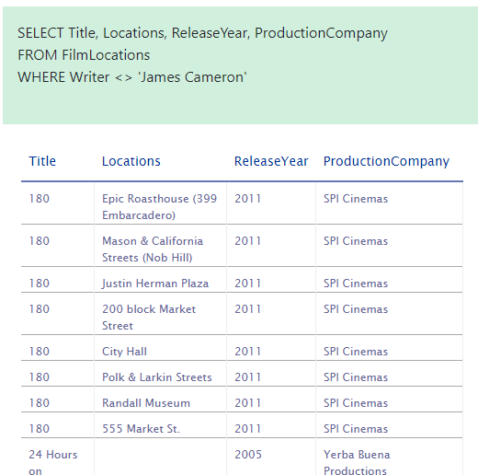

**Hands-on Lab : COUNT, DISTINCT, LIMIT**

**Task A**

* 1. Suppose we want to count the number of records or rows of the "FilmLocations" table.

*SELECT COUNT(*)*

*FROM FilmLocations*

*;*

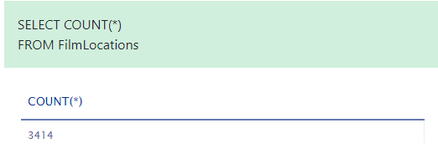

* 1. *Now we want to count the number of locations of the films. But we also want to restrict the output resultset in such a way that we only retrieve the number of locations of the films written by James Cameron*

*SELECT COUNT(Locations)*

*FROM FilmLocations*

*WHERE Writer = ‘James Cameron’*

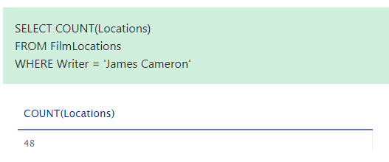

***Task B***

1. Problem:

*Retrieve the number of locations of the films which are directed by Woody Allen.*

*SELECT COUNT(Locations)*

*FROM FilmLocations*

*WHERE Writer = “Woody Allen”*

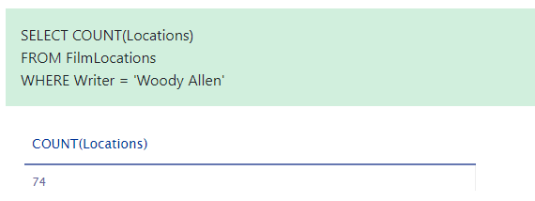

1. Problem:

*Retrieve the number of films shot at Russian Hill.*

*SELECT COUNT(Locations)*

*FROM FilmLocations*

*WHERE Locations = “Russian Hill”*

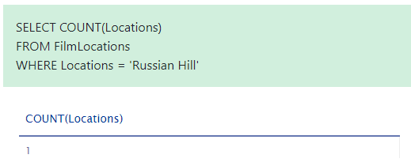

1. Problem:

*Retrieve the number of rows having a release year older than 1950 from the "FilmLocations" table.*

*SELECT \**

*FROM FilmLocations*

*WHERE ReleaseYear <1950*

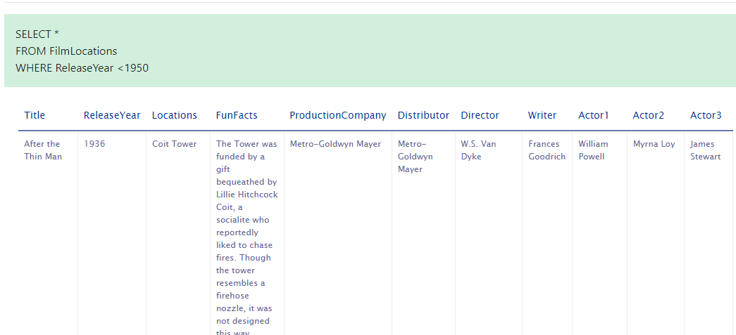

***Task A: Example exercises of DISTINCT***

* 1. We want to retrieve the title of all films in the table in such a way that duplicates will be discarded in the output resultset

SELECT DISTINCT Title

FROM FilmLocations

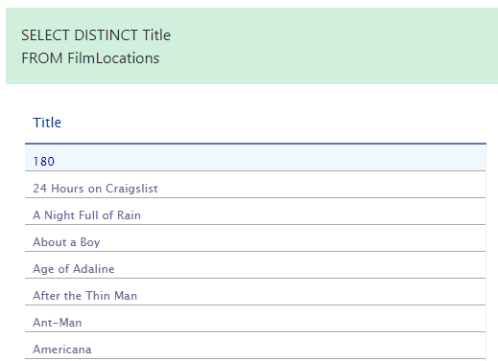

* 1. *We want to retrieve the count of release years of the films produced by a specific company in such a way that duplicate release years of those films will be discarded in the count.*

*SELECT COUNT(DISTINCT ReleaseYear)*

*FROM FilmLocations*

*WHERE ProductionCompany="Warner Bros. Pictures";*

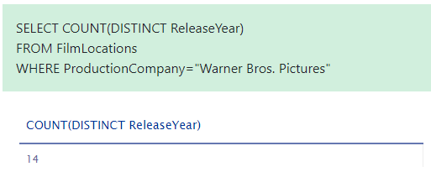

## Task B: Practice exercises on DISTINCT

1. Problem:

Retrieve the name of all unique films released in the 21st century and onwards, along with their release years.

SELECT DISTINCT Title, ReleaseYear

FROM FilmLocations

WHERE ReleaseYear>=2001

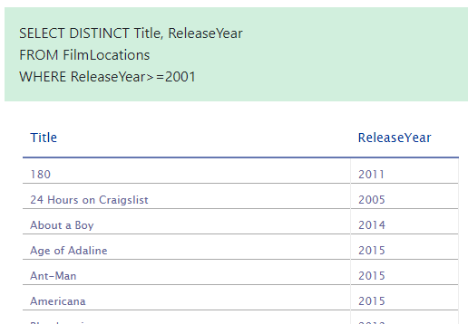

1. Problem:

Retrieve the names of all the directors and their distinct films shot at City Hall.

SELECT DISTINCT Title, Director

FROM FilmLocations

WHERE Locations="City Hall"

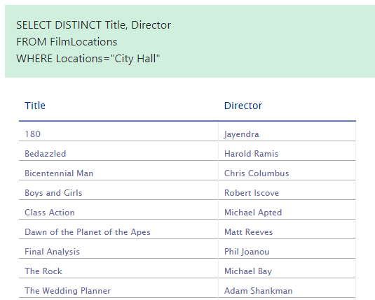

1. Problem:

Retrieve the number of distributors distinctly who distributed films acted by Clint Eastwood as 1st actor.

*SELECT COUNT(DISTINCT Distributor)*

*FROM FilmLocations*

*WHERE Actor1="Clint Eastwood";*

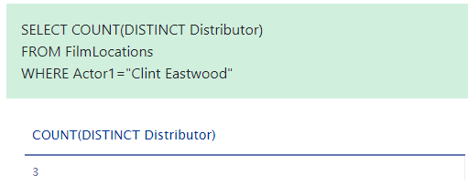

## Task A: Example exercises of LIMIT

Let us go through some examples of LIMIT related queries:

1. Let us retrieve a specific number of rows from the top of the table in such a way that rows other than those are not in the output resultset.

SELECT *

FROM FilmLocations

LIMIT 25

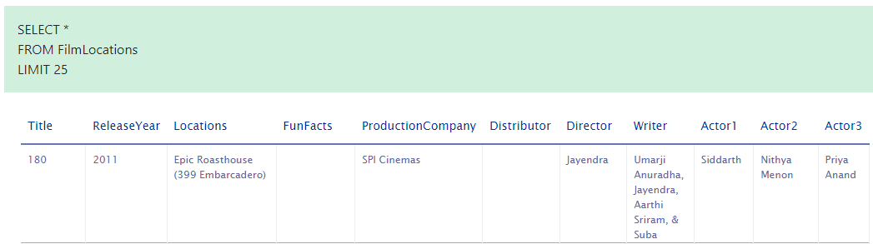

1. Let us take the first example to a more advanced level. Now we want to retrieve a specific number of rows from the table, but thid time, not from the top of the table. This time we want to retrieve a specific number of rows starting from a specific row in the table.

SELECT *

FROM FilmLocations

LIMIT 15 OFFSET 10;

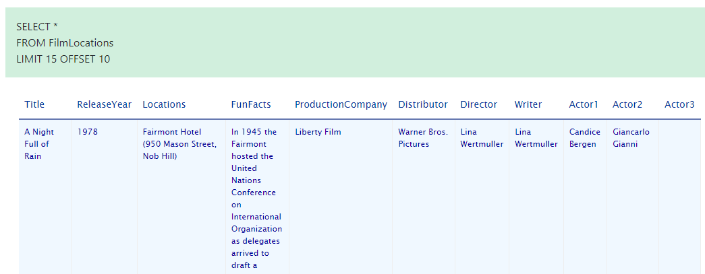

## Task B: Practice exercises on LIMIT

Now, let us practice creating and running some LIMIT related queries.

1. Problem:

Retrieve the name of first 50 films distinctly.

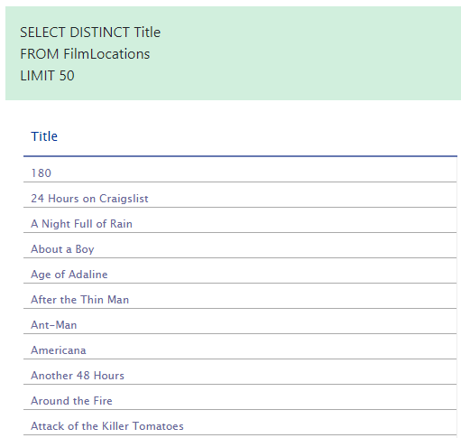

1. Problem:

Retrieve first 10 film names distinctly released in 2015.

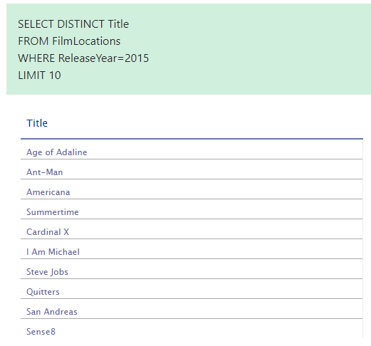

1. Problem:

Retrieve the next 3 film names distinctly after first 5 films released in 2015.

